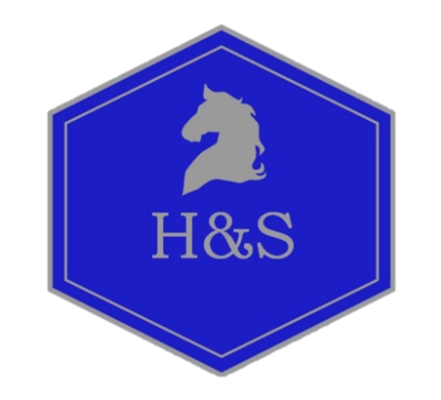

“Design Thinking” with the team at H&S

The Pony Porchester Mono Dressage for Adults.

What is design thinking?

It is a method of thinking that revolves around the understanding of people and animals for whom we are designing this product.

Done through observation, questioning of the process, the problem, the implications of a design and the assumptions surrounding an already agreed upon idea. It reframes a problem in human and equine ways, allowing the problem solver to adopt different ideas and combinations to better the product or system and make it more successful and user friendly.

The design team at H&S combine skills in human mechanics, rider sport mechanics and equine mechanics with modern, but traditionally based skills of leather work, saddlery design and engineering skills to produce products that are specific to solving problems for the horse and rider.
We think laterally towards build, conformation and action in both horse and rider, allowing ease of movement and correct postures.

Each saddle is individual, it is designed to allow for the stature of the rider and the horse.
THE PONY PORCHESTER MONO DRESSAGE is a true dressage saddle designed by our team and built individually to focus on the adult rider that rides and competes ponies or small horses.
Changes in longitudinal and lateral balance combined with a smaller aesthetic make this saddle perfect for the petite adult riding an extravagant pony.
